Product Design
Team  Members | Team Nova  Kris Sathwara, Sahil Chaudhari, Gauri Kaushik, Brandon Vojtkofsky

Revision Number | Revision Date | Summary of Changes | Author(s)
0.1 | 10/2/2026 | Document created | Team Nova
0.2 | 10/2/2026 | Initial Diagrams added | Kris S.
0.3 | 10/2/2026 | Initial design summary drafted | Brandon V.
1.0 | 10/2/2026 | Design Rationale Added | Sahil C.
1.1 | 10/15/2026 | Updated Class Diagram and ER Diagram | Kris S.
2.0 | 10/15/2026 | Added User Interface Screenshot | Sahil C.

Class Diagram(s)
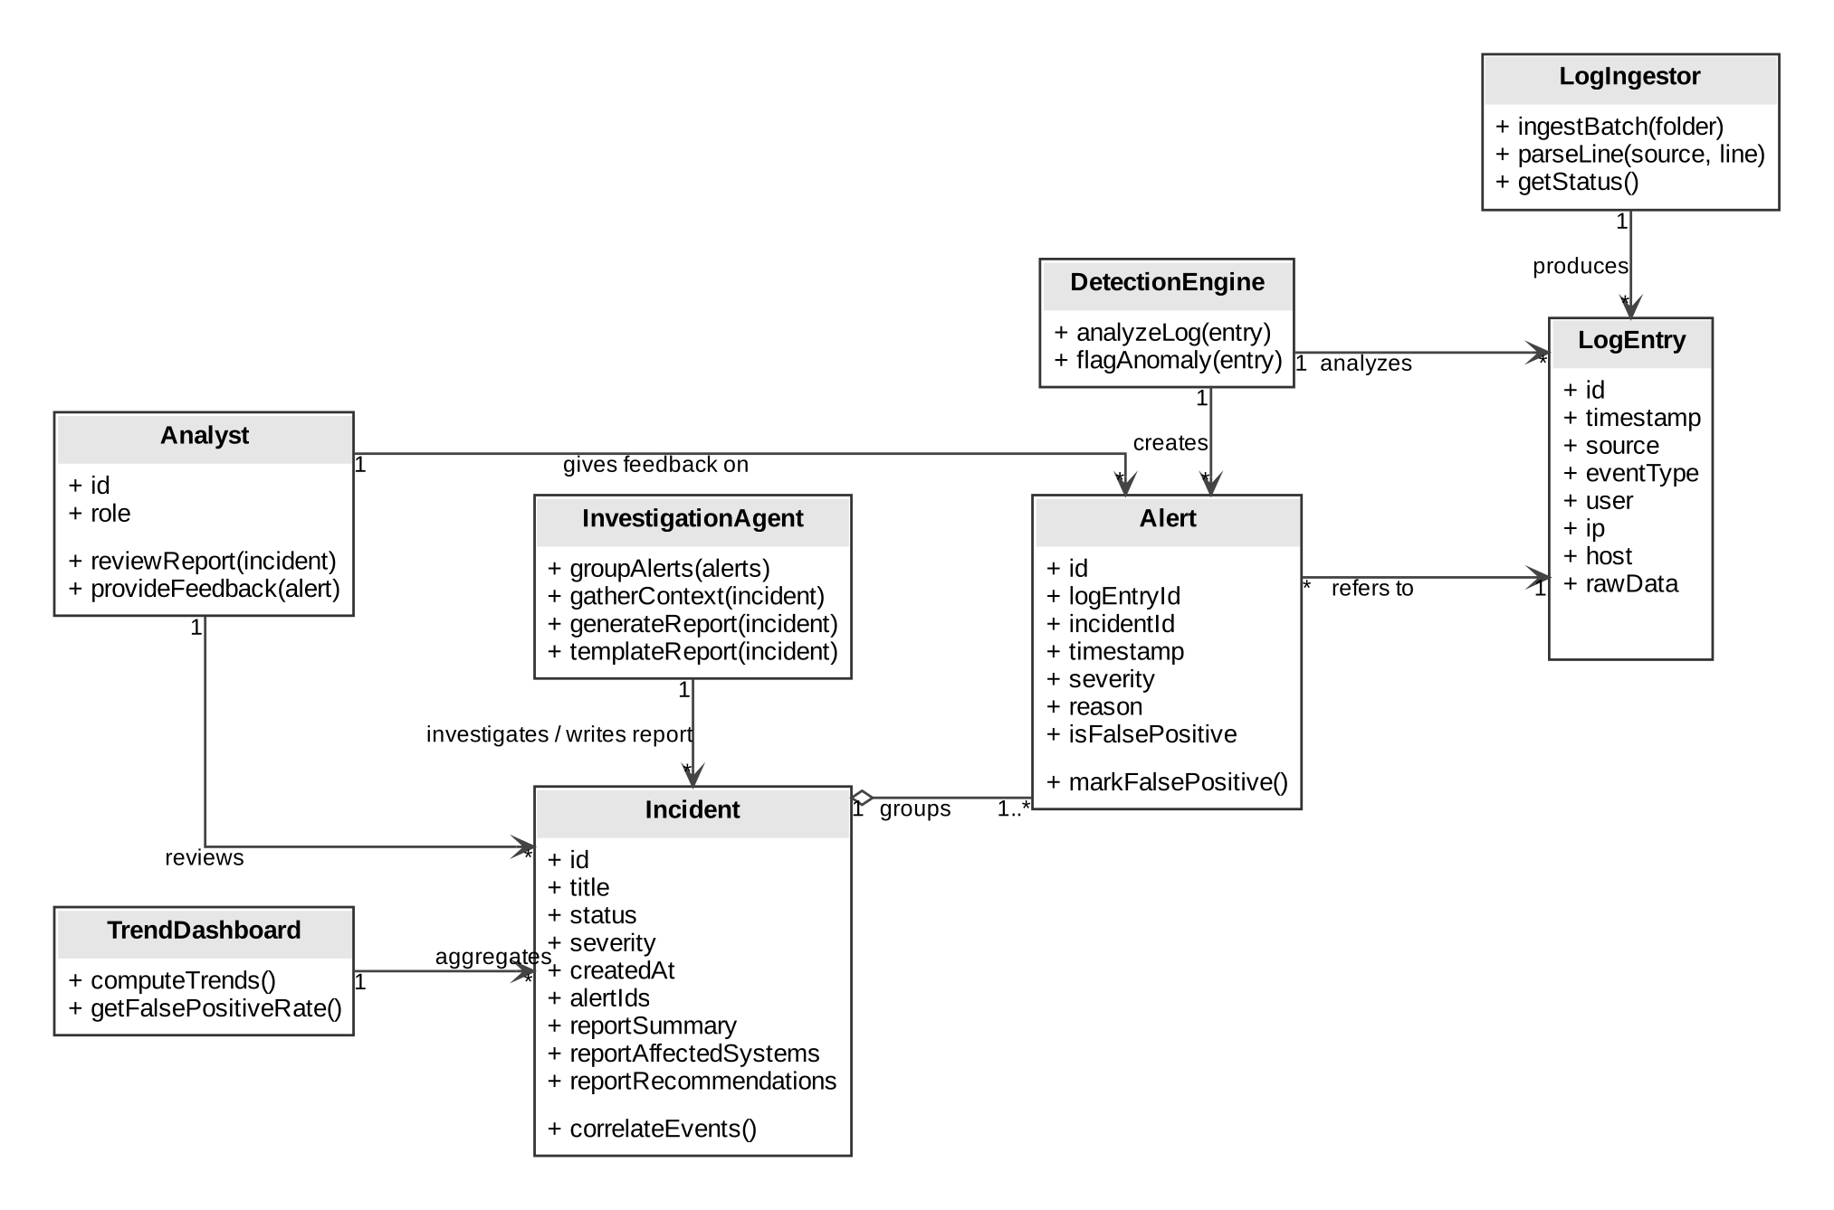

ER Diagram(s)
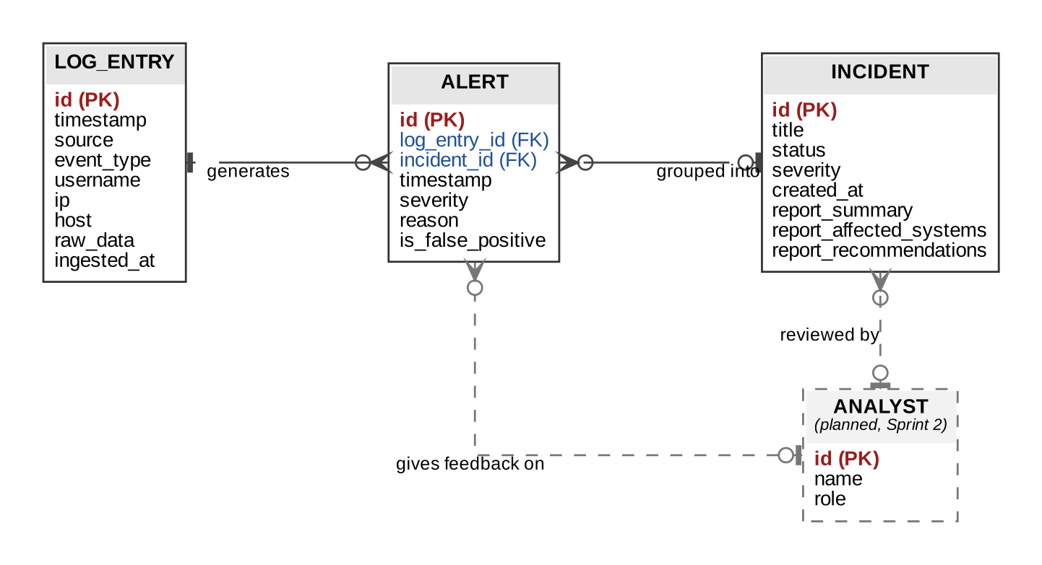

Information Architecture Diagram
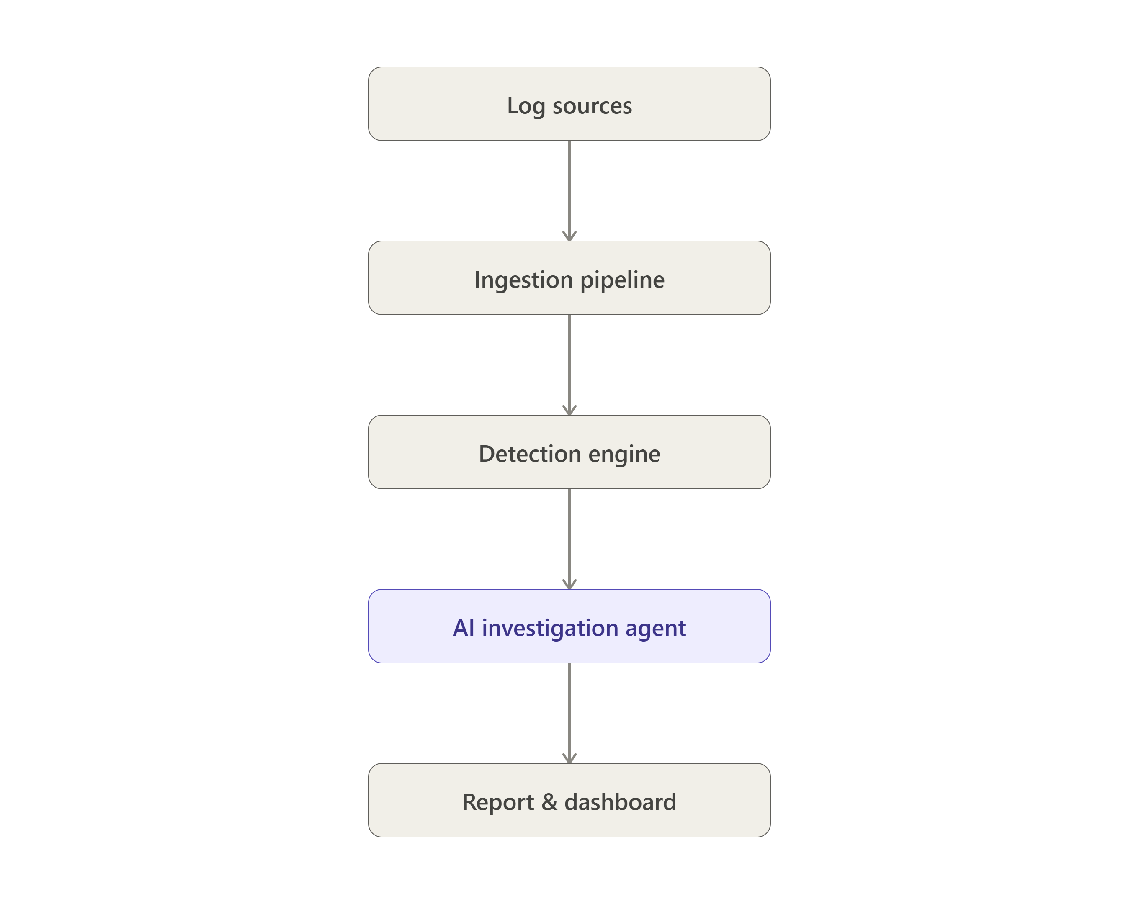

User Interface Wireframe(s)/Screenshot(s)

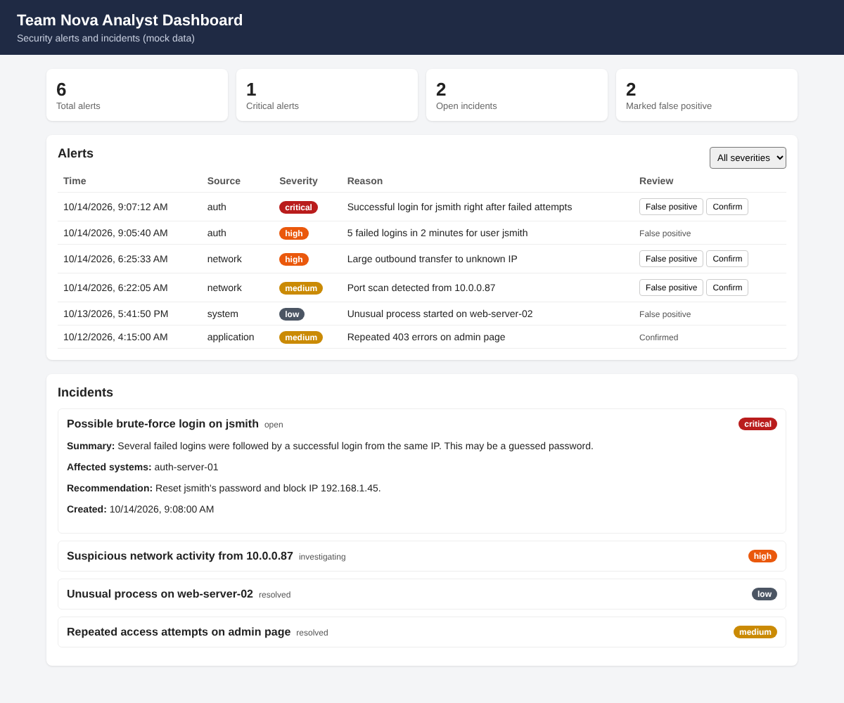

Design Summary
Our current vision for the project sees a general flow of data fed into the system by the user in the form of log files. Log sources flow down to the ingestion pipeline which produces standardized log entries. These entries are passed to the detection engine which uses them to produce alerts that are then grouped into incidents. each incident is then analyzed by the AI investigation agent which generates a descriptive, concise, easily-readable report that it then presents on the dashboard where the human analyst can provide the system with feedback to improve the quality of reporting.

Design Rationale
1. Pipe-and-filter vs. monolithic architecture — Monolithic would block ingestion on slow AI investigation calls. Chose pipe-and-filter: independent stages (ingest/detect/correlate/investigate/report), easier to divide across teammates and swap components later.
2. Hybrid detection vs. rule-only or ML-only — Rules alone miss novel attacks; ML alone is hard to explain/validate in two semesters. Chose hybrid: rules catch known patterns, ML catches subtler anomalies.
3. Relational DB vs. document store — Our data (logs→alerts→incidents→reports) has clear FK relationships. Chose relational for referential integrity and easier querying for the trend dashboard.
4. Decoupled Investigation Agent vs. embedding it in Detection Engine — Embedding ties detection uptime to LLM latency. Chose a separate stage so investigation logic can change without touching detection.

